”Follow me” controller

Course: Grundlæggende Indlejrede Systemer (GiS)
Modul 3, Regulering af dynamiske systemer
Group: Group N
Date:
Names: Thomas Ginnerup Kristensen
Henrik Arentoft Dammand
Anders Hvidgaard Poder

Ændring af grundstruktur i rapporten så det passer med miniprojekt beskrivelsen side 2 (beklager, den havde jeg helt overset)

Description
Create a regulator that allows a car to follow another car at a predefined distance.

Tegningen er ændret så bilerne kører i x-retningen

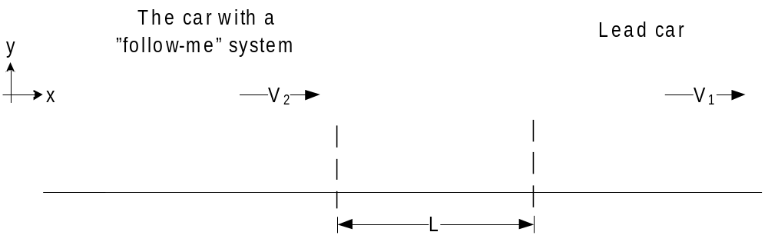Overall view of the ‘follow me’ system

The ‘follow me’ system illustrated above consists of two vehicles. The front car leads the way while the rear vehicle automatically follows the front vehicle at a fixed distance. The ‘follow me’ system continuously measure the distance to the front vehicle and automatically make adjustments to uphold the fixed distance.

The overall regulator may be seen in the below drawing
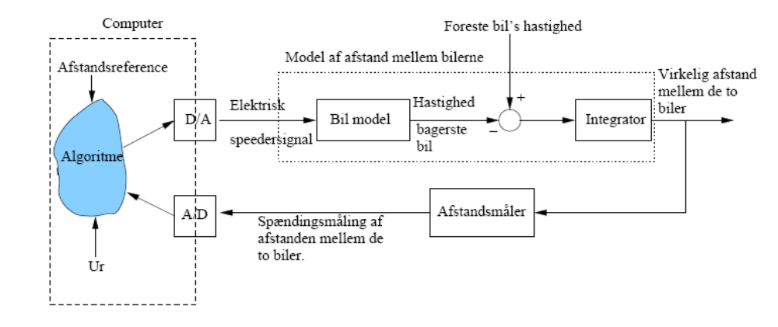

Model

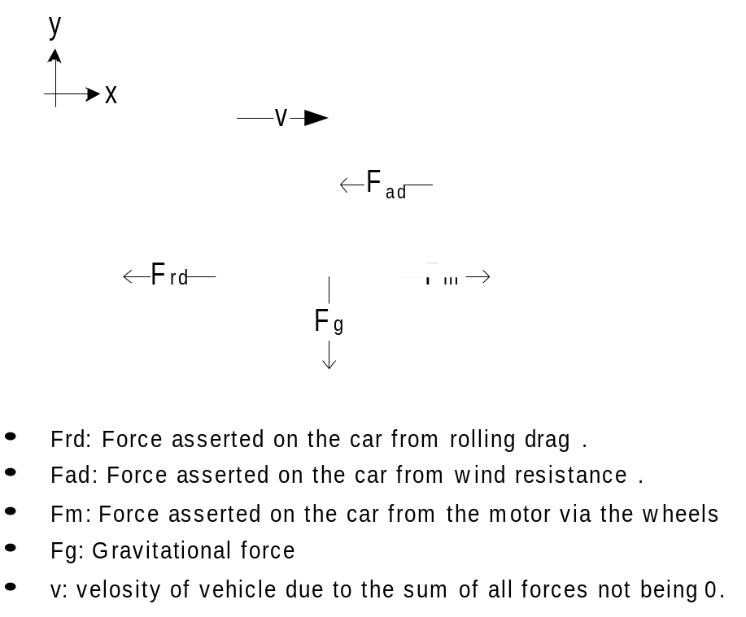
Free body diagram of the ‘follow me’ vehicle

- F_{rd}: Force asserted on the car from rolling drag.
- F_{ad}: Force asserted on the car from wind resistance.
- F_{m}: Force asserted on the car from the motor via the wheels
- F_{g}: Gravitational force
- v: velosity of vehicle due to the sum of all forces not being 0.

In the free body diagram above is only shown the overall forces affecting the system. Many, many has been ignored because they are negligible. A complete list will not be supplied, as it is almost always possible to come up with some that has not been considered. To give a few examples may be mentioned

- The capacitance generated between the windings in the endian – considered to have a negligible effect compared to the inductance and resistance.
- The initial friction resistance, which is non-linear and lager than the friction resistance lim car velocity -> 0.
- The temperature dependency of the tires spring effect.
- The loss in the transfer of torque from the engine shaft to the wheels.
- And so on and so on.

And this does not even include the assumptions made in the assignment (ignoring hills and bumps and turns and changes in wind-strength).

Finally, since there is no changes in the road (no hills, no bumps) and we ignore the breaking and acceleration effect on the suspension (since the car has no breaks, we can simply assume that it has four-wheel-drive, and then the acceleration and breaking should be evenly distributed), we can ignore the effect of the tires and suspension, making the model much simpler.

Having no bumps, hils or turns (centrifical force is relative to mass and speed), and considering the tires ideal, the gravity force, being direrctly proportional to the other forces, irellevant. This means that Fg can be ignored.

The contribution from the rolling drag (F_{rd}) can be calculated by

 eq. 1

C_{rr} is the dimensionless rolling resistance coefficient. On a smooth road and low-resistance car tires the C_{rr} coefficient is low. In order to further simplify the model we assess the contribution from rolling drag to be negligible; hence we can eliminate F_{rd}.

This leave air drag F_{ad}, which act as an opposite force to the vehicle’s moving direction and is propotional to the velocity of the vehicle. For a matter of simplicity we make the air drag linear proportional to the velocity.

 eq. 2

The coefficient b is dimensionless constant. The air drag equation is appropriate at relative slow speed (I.e. low Reynolds number, R_{e} < 1). However, we assume the air drag equation is valid for all speeds.
Using Newton’s second law that states that the net force applied to the vehicle produces a proportional acceleration we have:

F = m * a eq. 3

where F is the total force asserted on the mass (with sign and direction) so the equations can be collected to

F_{m} – bv = m * a => F_{m} – bv = m * dv/dt eq. 4

The force F_{m} is the net force from the vehicle’s wheels



From the free body picture of a wheel we can establish an equation that gives the net torque applied to the wheel.

 eq. 5

We combine eq. 4 with eq. 5 and we have:

TODO: verify sign

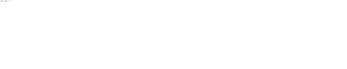 eq. 6
The torque t_{m} in eq. 6 is the contribution from the vehicle’s DC motor. A simplified model of a DC motor is shown below



TODO: should we include L???

The DC motor’s torque is a linear proportional to the current and is motor torque constant and we have:

 eq. 7

We can derive eq. 7 into angular momentum and we have:

 eq. 8

The DC motor’s angular velocity is defined as a linear voltage difference, proportional to the angular velocity of the armature shaft and  and we have:

 eq. 9

By using Kirchoff’s laws the following equation can be derived



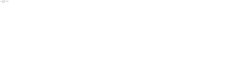







 eq. 10

In eq. 10 the torque from the DC motor has been found and can be inserted into eq. 6 and we have:



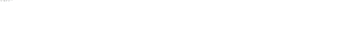

 eq. 11

Equation 11 is reduced to interacting forces as a change of velocity over time and voltage. For simplicity we replace all the constants in reduced form:







The parameters are explained below:
Mass of the vehicle
Inertia of the vehicle’s wheel
Radius of the wheel
Electrical resistance in the motor
Angular velocity constant
Torque constant
Wind resistance coefficient

And we can rewrite equation 11:

 eq. 12

Equation 12 in Laplace transformed version we have:



 eq. 13

The equation 13 can be rewritten and we find the vehicle’s transfer function

 eq. 14

Simulering

Kontrolspecifikationer

Kontroldesign

Afprøvning

References

